What are they hiding?': Group sues Biden and National Archives over JFK assassination records
President Joe Biden last year postponed the release of 16,000 records until Dec. 15, 2022, but the Mary Ferrell Foundation says in its lawsuit the delay was illegal.
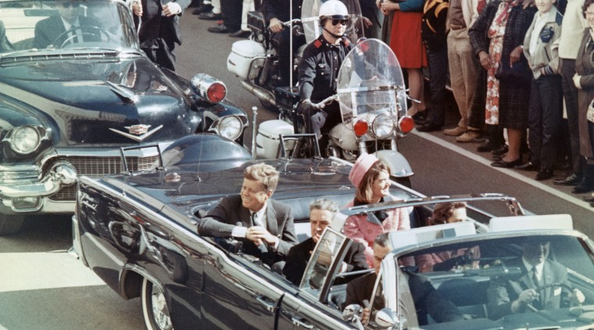
President John F. Kennedy and first lady Jacqueline Kennedy smile at the crowds lining their motorcade route in Dallas on Nov. 22, 1963.Bettmann Archive file

Oct. 19, 2022, 6:00 AM EDT
By Marc Caputo
The country's largest online source of JFK assassination records is suing President Joe Biden and the National Archives to force the federal government to release all remaining documents related to the most mysterious murder of a U.S. president nearly 60 years ago.
The Mary Ferrell Foundation filed the federal lawsuit Wednesday one year after Biden issued a memo postponing the release of a final trove of 16,000 records assembled under the President John F. Kennedy Assassination Records Collection Act of 1992, which Congress passed without opposition in response to Oliver Stone's Oscar-nominated film “JFK.”
The JFK records act, signed by former President Bill Clinton, required that the documents be made public by Oct. 26, 2017, but President Donald Trump delayed the release and kicked the can to Biden, who critics say continued the policy of federal obfuscation that has existed since Kennedy was assassinated Nov. 22, 1963, in an open motorcade at Dealey Plaza in Dallas.
“It’s high time that the government got its act together and obeyed the spirit and the letter of the law,” said the vice president of the nonpartisan Mary Ferrell Foundation, Jefferson Morley, an expert on the assassination and the CIA.
“This is about our history and our right to know it,” said Morley, the author of the JFK Facts blog.
Morley’s sentiment is shared by fellow historians, open government advocates and even some members of the Kennedy family, who usually don’t comment on the assassination.
“It was a momentous crime, a crime against American democracy. And the American people have the right to know,” said Robert Kennedy Jr., the son and namesake of JFK’s brother. “The law requires the records be released. It’s bizarre. It’s been almost 60 years since my uncle’s death. What are they hiding?”
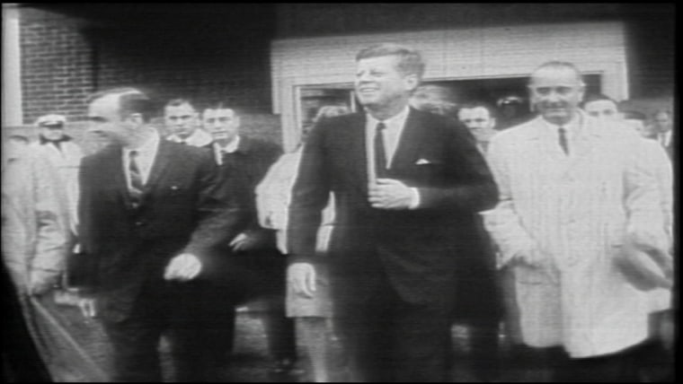

Insight: The JFK Assassination Files
OCT. 26, 201702:55
Most experts believe that the unreleased or heavily redacted records almost certainly don’t include irrefutable proof that shows others were complicit in the murder of Kennedy along with accused shooter Lee Harvey Oswald.
What the records would shed more light on, they say, is a seminal period in American history linked to JFK’s presidency and assassination: Cold War operations by U.S. intelligence agents, U.S.-Cuba relations and the plot to kill dictator Fidel Castro, and the war on the Mafia waged by then-Attorney General Robert F. Kennedy, who was assassinated five years after his brother.
The hidden documents, however, could also show something potentially more sinister: CIA contacts with Oswald while Kennedy was still alive, which the CIA has repeatedly covered up, according to experts like Rolf Mowatt-Larssen, a former CIA agent who is critical of the agency and has lectured about JFK's assassination at Harvard University.
“What I think happened, in a nutshell, is that Oswald was recruited into a rogue CIA plot,” Mowatt-Larssen said. “This group of three, four or five rogues decided their motive [was] to get rid of Kennedy after the Bay of Pigs and the Cuban Missile Crisis because they thought it was their patriotic duty given the threat the country was under at the time and their views, which would be more hard-line or more radically anti-communist and very extreme politically.”
In a statement to NBC News, the CIA said it is adhering to the JFK records act and Biden’s memo, which called for the release of the documents by Dec. 15, 2022. The National Archives and Records Administration, the agency in charge of the JFK documents, also said it’s complying with the law and the procedures Biden outlined.
But the lawsuit, filed Wednesday in San Francisco federal court, argues that the federal agencies haven’t followed the law and that both Biden’s executive order and Trump's previous delay violated the 1992 statute, creating new loopholes and avenues for further unjustifiable postponements after six decades of opacity.
The suit asks a judge to declare Biden's memo void and disclose the records as Congress intended 30 years ago. Biden’s memo blamed the coronavirus pandemic for slowing the disclosure process, an argument rejected by the foundation’s attorney, Bill Simpich.
“It’s a ‘dog ate my homework’ argument,” Simpich said. “This case is all about delay. The agencies always have new and better excuses.”
The foundation fears that agencies haven’t made enough progress in the year since the memo was issued in meeting the basic rules of disclosure under the JFK records act, necessitating the lawsuit.
The 16,000 documents are among the most sensitive records concerning JFK’s assassination. About 70% of them are controlled by the CIA, followed by the FBI, which is in charge of about 23% of the records, according to Morley’s count.
The suit alleges the federal government unlawfully redacted 11 specific records, including: a 1961 memo to reorganize the CIA after the failed Bay of Pigs invasion in Cuba, personnel files of three CIA officers tied to Oswald, a 1962 Defense Department “false flag” plan to stage a “violent incident” in the U.S. that would be blamed on Cuba, records relating to the Castro assassination plot, and a JFK document removed from Watergate burglar E. Howard Hunt’s security file.
The foundation is also asking the court to order the National Archives to find records that are “known to exist but that are not part of the JFK Collection.”
One of those records, according to the lawsuit, concerns George Joannides, who was the chief of covert action at the CIA’s Miami station and “served as case officer for a New Orleans-based CIA-funded exile group that had a series of encounters with Lee Oswald in 1963.” The lawsuit accuses the CIA of wrongly withholding files related to Joannides from the National Archives.
In another instance, the lawsuit asks the court to compel the public release of taped recordings of a man named Carlos Marcello, who allegedly told a cellmate that he was involved in JFK’s assassination. Transcripts of the recordings exist, but the foundation wants to hear the recordings to “fully evaluate the veracity and significance of these conversations.” Marcello died in 1993.
The foundation says the timing of the lawsuit is coincidental to Trump’s fight over classified records with the Justice Department and the National Archives, an agency that is seldom in the news but now plays a central role in the investigation of records stored at Trump's Mar-a-Lago club in Florida after he left office.
JFK assassination historian David Talbot, a Trump critic, said he sees an irony in the two cases.
“They decided to pillory Trump over this issue because he’s a political enemy, but they’re guilty of violating records laws themselves with the JFK records act: Trump took documents the federal government owned, but they’re sitting on documents that belong to the American people,” said Talbot, the author of “Brothers: The Hidden History of the Kennedy Years” and “The Devil’s Chessboard,” about the rise of the national security state.
A spokesman for Trump declined to comment.
Talbot said the agencies' stonewalling and the Warren Commission’s disputed conclusion in 1964 that Oswald was a lone wolf has only led people to mistrust the government.
An expert on conspiracy theories, Joseph E. Uscinski, a University of Miami political science professor, says his polling and research have shown that a majority of Americans don’t believe Oswald acted alone, making it the most popular conspiracy theory in the country.
Uscinski said he’s hesitant to draw a direct line between lack of trust in the government and the refusal to release the JFK records, but he argued the feds essentially have themselves to blame.
"The whole argument about documents is stupid. The CIA is wrong. All of this should have been released a long time ago, and it’s shameful the government has yet to do so," Uscinski said. "At the same time, there’s not a document sitting in a government vault somewhere that says, ‘We did it.’

